

**2022 Annual**

**St. Johns Soil & Water Conservation District**

**Public Speaking Contest**

**Where: St. Johns County Ag Center**

**Conference Room**

**3125 Ag Center Road**

**St. Augustine, Florida 32092**

**When: Wednesday, June 22, 2022**

**Time: 9:00 a.m.**

**TOPIC:**

**Healthy Soil /Healthy Life**

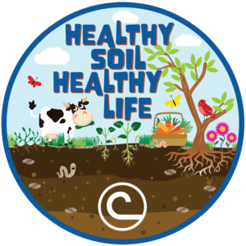

**Rules:**

* The Public Speaking Contest is open to any student in St. Johns County attending school (public, private, virtual, and/or home-school) in grades 6th through 12th. Contestants can speak on any subject within the topic.
* Contestants must register by emailing a completed registration form and copy of their speech, doubled spaced, by June 15th to Gina Allen at gina.allen@fl.nacdnet.net
* Each speech should be identified with one cover page that includes the student’s name, address, telephone number, grade, school, and teacher’s name.
* Contestants may use notes while speaking, visual aids may not be used.
* Time limit is 5-7 minutes. Penalties will be given for less than 5 minutes or more than 7 minutes.
* Three judges and one timekeeper will be selected. Judges’ decisions will be final. Judges will evaluate both written speech and oral presentation based on the following criteria.
* **JUDGING CRITERIA:**
* **Content:**

Relevance to the given topic 10 points  
Treatment (material used and accuracy of statements) 20 points  
Originality (subject matter and treatment) 20 points

* **Composition:**

Organization, cohesiveness, grammar, and style 10 points

* **Delivery:**

Voice (enunciation, modulation) 10 points  
Personal Appearance (neatness, posture) 10 points  
Communicative Expertise (sincerity ability to convey idea) 10 points  
Stage Presence (gestures, visual contact) 10 points

**The following prizes will be awarded to each winning contestant:**

**First Place - $100.00**

**Second Place - $50.00**

**Third Place - $25.00**

**DEADLINE FOR SUBMITTING SPEECHES IS JUNE 15, 2022.**

**PLEASE EMAIL TO** [**GINA.ALLEN@FL.NACDNET.NET**](mailto:GINA.ALLEN@FL.NACDNET.NET)